Hashing

**Task:**

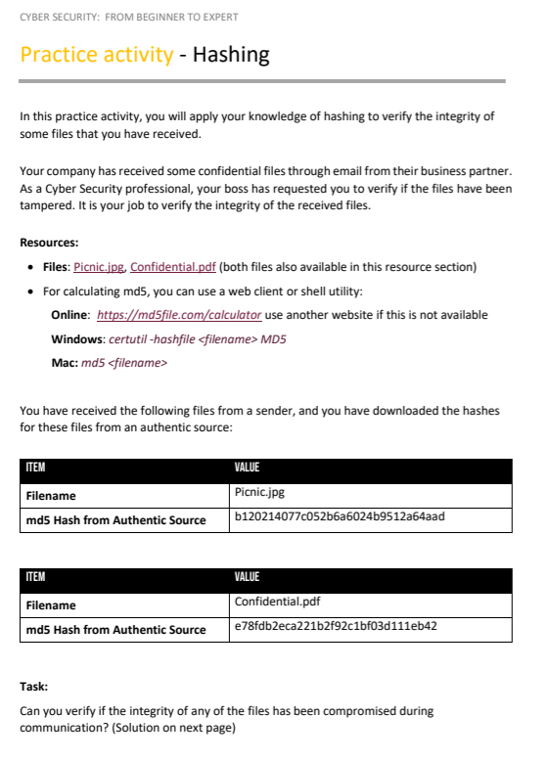

**Solution:**

**1st file**

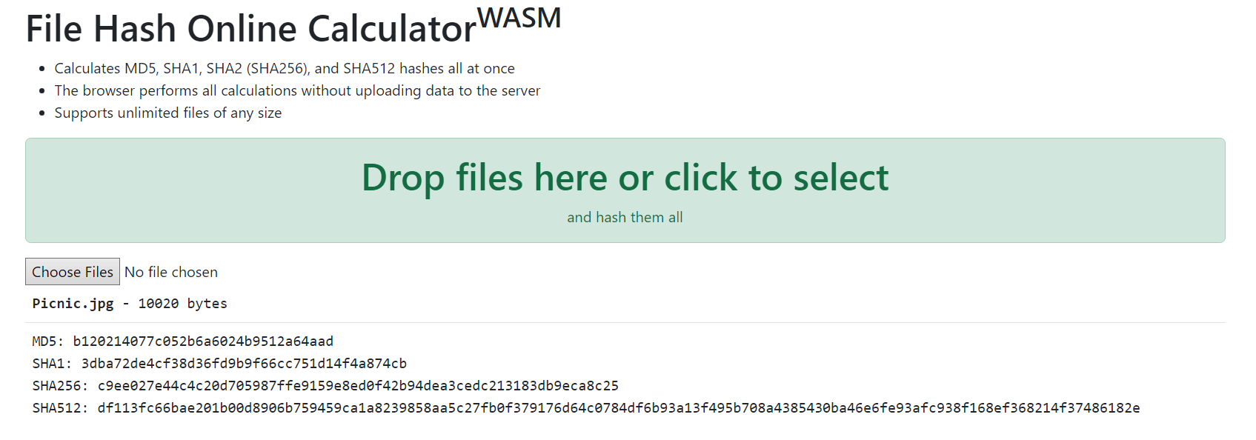

Md5 hash given: b120214077c052b6a6024b9512a64aad  
md5 hash calculated: b120214077c052b6a6024b9512a64aad

Comparing = integrity is **INTACT**

**2nd file**

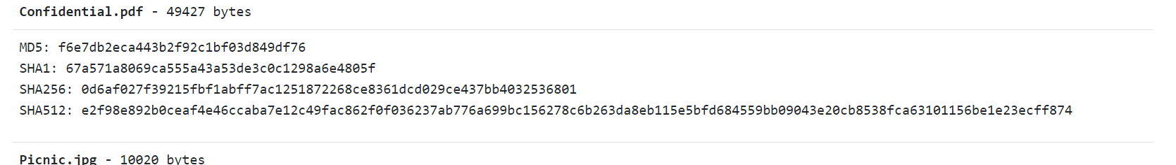

Md5 hash given: e78fdb2eca221b2f92c1bf03d111eb42  
md5 hash calculated: f6e7db2eca443b2f92c1bf03d849df76

Comparing = integrity is **NOT INTACT**

*This file may have been modified.